12252019 Notes on DSC simulation fit

curvefit_simulation_toDSC.m

/Users/nathanaelkazmierczak/Dropbox/NPKHardDriveBackupFall2017/workspace/BediakoResearch/DSC_BlinkingFit/Simulation1DSCReconResults

Here are the blinking maps from the electron diffraction raster simulation:

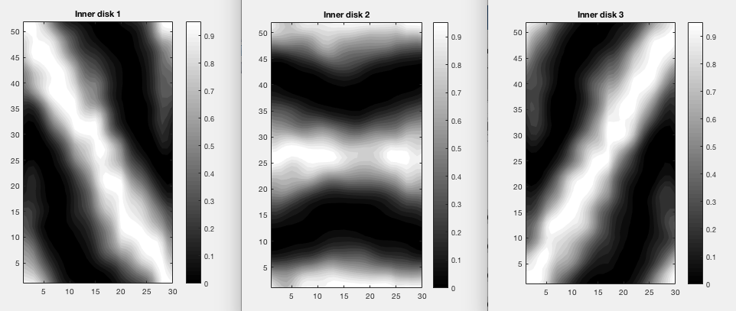

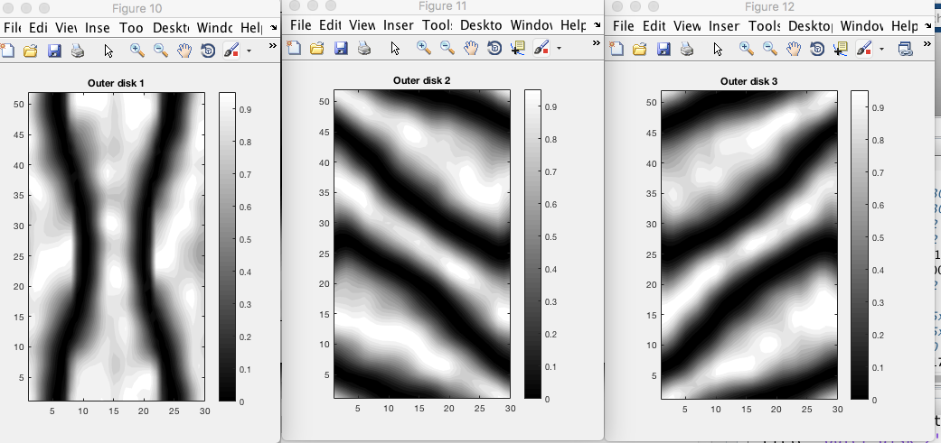

Here are the simulation reconstructions of the DSC lattice and the DSC scatterplot:

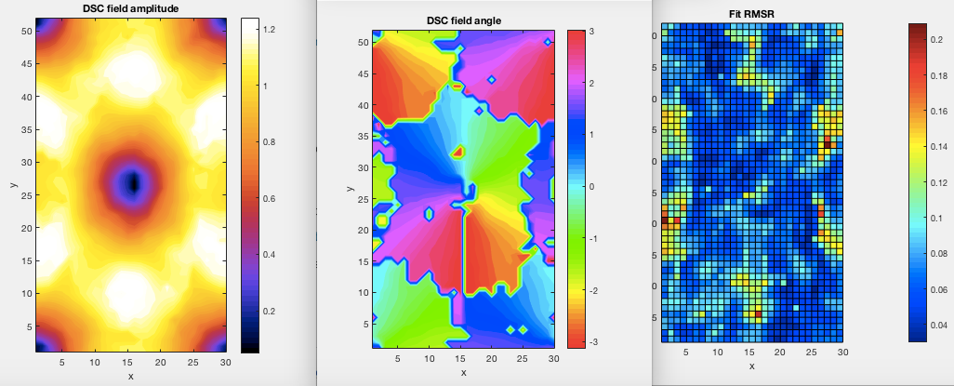

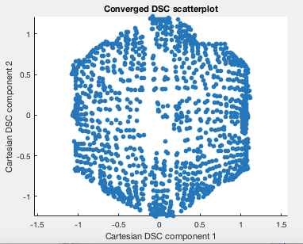

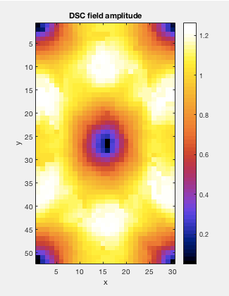

This is the amplitude field blown up so you can see the resolution.

Here is the ground truth lattice used for the simulation (recall that this was the old faulty reconstruction function):

(comparison of reference versus calculated:

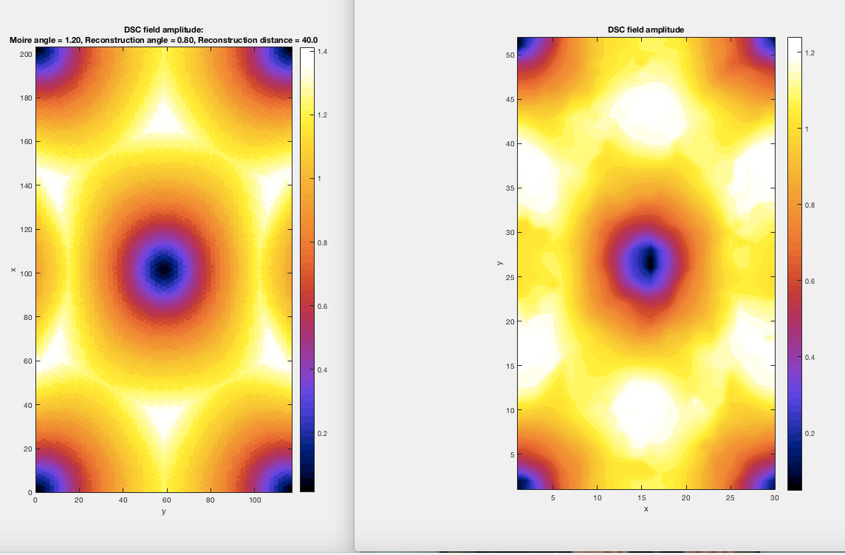

(Note the difference in the colormap scale, which surely comes from misrepresentation of the edges of the hexagon in my interpolation fitting simulations.)

Here is the angle plot. Note that there is something going on in the fit which causes it to have the angles moving differently than expected. I’m not sure why that is.

